Internship organization name:
VUES (Virtual University & Expert System)- American International University Bangladesh

Position name:
Student Assistant

Responsibilities:
My main responsibilities were to assist the head of IT-operations in his day to day activities,
such as:
- Documentation of AIUB website (http://www.aiub.edu/)
- Upload Notices, News & Events to different departments website approved by department coordinator.( ex. `http://fass.aiub.edu/, http://mmc.aiub.edu/)
- Assisting the faculty on their requests.
- Providing support to student all requirements.
- Maintain documentation related to faculty and students.
- Help to prepare pre-registration and registration for upcoming semester.
- Assist in encoding the courses and documents in UMS (university management system)

Convocation:
A student officially finishes his\her academic degree through convocation. IT operations have the following tasks to perform before a student can be cleared for convocation.
- Mapping student’s grades
- Checking curriculums of the student
- Checking accounts of the student
- Checking waiver, dropping, invalid subjects and their grades.
All of the above process is performed as per the policy set by the university.

Registration:
Registration is one of the important tasks of any University. It is the process through which any student gets enrolled in to a new semester. Registration process in AIUB can be divided in to two parts:
- Freshmen enrollment
- Enrollment of existing student in to a new semester

For both the process to perform, the IT operations of AIUB have quite some tasks to perform like:
- Creating code number, timing, room number and capacity for individual sections in the system.
- Encoding those code number, timing, room number and capacity in the system.
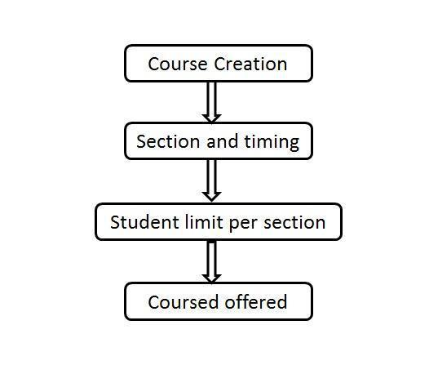
- Increasing capacity limit of each class upon request from the department head as per university policy.
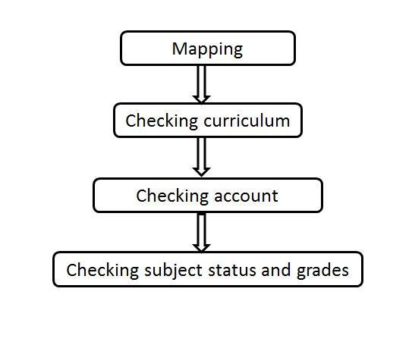

Fig: Course offering for registration Fig: Convocation clearance steps

Organization- Wide
- ID Card Distribution
- Distributing Exam Permit
- Course creation, section, timing , course offered
- Course Dropping and scanning documents
- Project and Thesis group Creation and student Allocation
- Convocation Clearance

